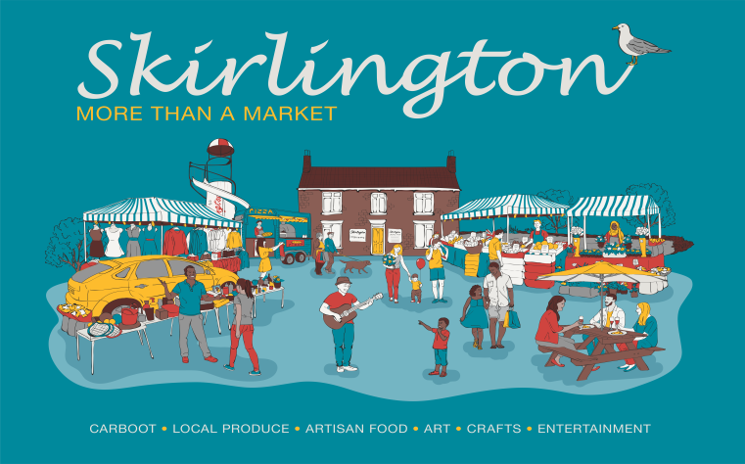
Market Trader Application
Skirlington Market
Hornsea Road
Skipsea
East Yorkshire
YO25 8SY
Tel 07742 275196

Dear Trader
Thank you for your enquiry about a stall at Skirlington Market.
Regular Stall: To book a regular pitch, one weeks advance fee is required. The fee will then be collected each week. This will mean that you are paying one week in advance to guarantee your pitch. If you decide to finish, you stop paying the fees and continue to work for the period of your advance fee and then leave. No pitch can be allocated unless the fees are paid. The Management also reserve the right to issue you with notice to finish trading at the market or to move stall/location and will honour the notice period/ advance fee payments. Traders leaving items on our site: (this must only be items that have prior agreement with the management). Items left on a stall including non-market days, are left entirely at your own risk. We do not accept any reliability for loss or damage caused by theft, fire, storm damage or any other source.
Casual Stall: Traders can trade on a casual basis by attending the Market on the morning of each Market day to see if there are any empty stalls/spaces available. Prospective traders need to be at the Market Office by no later than 8.30am All casual traders must complete a Casual Registration Form on arrival and have Public Liability Insurance, acknowledge that they have carried out a Risk Assessment and familiarise themselves with the Fire Plan. Allocation of stalls is determined on the following criteria: Trading history, Product lines to be carried, availability of market stalls.
Pre-Booked Stalls, Indoor Market: Traders can book indoor stalls a week in advance subject to availability. Failure to attend without cancelling will mean that you are not able to pre-book stalls in the future.

The Application Form must be completed and handed to your Manager or emailed to skirlington2@yahoo.co.uk.
We recommend traders to use Green and White striped covers for outdoor stalls. No stall coverings are permitted inside. All traders must have Public liability insurance and have carried out a Risk Assessment. In the event of an incident, you could be held responsible and your insurance company would deal with any claim. Any Trader erecting their own stall or Gazebo must ensure that the structure Is safe and follow the manufacturers guidelines and safety standards. Structures such as Gazebos MUST be anchored down at all times (whatever the weather). All indoor traders are required to have a small, in-date fire extinguisher.

Insurance Options: Please call one of the companies below, prices start from approx. £50 for the year; Combined Market Traders Insurance; 0208 554 5273 LRO: 0207 3475160 GM Imber: 01342 327250 National Market Traders Federation 01226 749021

Food Sellers:

Caterers; We will require an in date copy of your Public Liability Insurance, Risk Assessment (including Fire Risk Assessment)and PSSR certificate (if using pressurised systems such as coffee machines). All electrical items and installations must be PAT tested and Gas items must have a Gas Safety Certificate. Caterers must hold suitable Fire Fighting equipment and be trained how to use them. Any seating provided must be fit for purpose and not interfere with designated walkways. Caterers must also provide relevant Allergen Information.

We will require copies of all documentation to be kept on file.

Under UK law, if you are operating or intending to operate a food business, you need to register this (including market stalls, delivery vehicles and other movable structures). Registration allows local authorities to keep an up-to-date list of all premises in their area so they can visit them when they need to.
If you run a food business in East Yorkshire please contact Environmental Health on 01482 393939 to determine what is required. There’s lots of information online and also the facility to register at www.eastriding.gov.uk/business

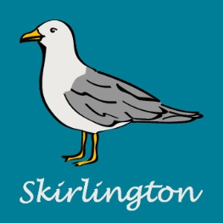
APPLICATION FORM TO PRE-BOOK AN INDOOR STALL:
Contact name:
Trading name:

Named partners:

Address:

Postcode:
E-Mail:

Telephone: Home: Mobile:

Full Description of Goods Sold:

How many stalls do you require (Our stalls are 10 foot)?

Dates Requested (availability to be confirmed via email)

My Public Liability Insurance details are as follows:-
Name: Policy Number:
Renewal Date:
Risk Assessment carried out on (Date)
The information given here is CONFIDENTIAL and will ONLY be used by Skirlington in the operation of our markets and will not be passed on to any other persons, unless required by law to do so.
I have read and agree to abide by the Rules as published by the operators and I will familiarise myself with the Fire Safety Plan on arrival.
Signed: Name
Date:
REGULAR/CASUAL TRADER APPLICATION FORM:

Contact name:

Trading name:
Named partners:
Address:

Postcode:
E-Mail:
Telephone: Home: Mobile:
Full Description of Goods Sold:

Pitch Size Front (ft): Depth (ft):
Do you demonstrate? : Yes/No

My Public Liability Insurance details are as follows: -
Name: Policy Number:
Renewal Date:
Risk Assessment was carried out on (Date)
The information given here is CONFIDENTIAL and will ONLY be used by Skirlington in the operation of our markets and will not be passed on to any other persons, unless required by law to do so.
ALL STALLS AND PITCHES ARE LET SUBJECT TO AVAILABILITY AT THE TIME OF RECEIPT OF THE ADVANCE FEE
I have read and agree to abide by the Rules as published by the operators. I will familiarise myself with the Fire Safety Plan. If erecting my own stall/gazebo I acknowledge that this will be Structurally sound and anchored down. I will follow manufacturers guidelines for safety.
Signed: Name
Date:

